| **Test Name** | | | Test one match adds 2Xbet to balance. | | | |
| --- | --- | --- | --- | --- | --- | --- |
| **Use Case Tested:** | | | Play Game | | | |
| **Test Description:** | | | Tests that when the player makes two matches, he receives 2X his bet added to his balance. | | | |
| **Pre-conditions** | | | Bug 4 must be resolved (producing new dice faces with each roll). | | | |
| **Post-conditions** | | | GameTest unit test has passed. | | | |
| **Notes:** | |  | | | | |
| **Result (Pass/Fail/Warning/Incomplete)** | |  | | | | |
|  | **TEST STEP** | | | **EXPECTED TEST RESULTS** | P | F |
|  | Run TestRunner.java | | | Console opens and unit test results are shown. |  |  |
|  | Look for this line in the console: “TestPlayRoundTwoMatches(test.GameTest): expected:<150> but was:<125>” | | | This line should not exist. |  |  |
|  | Look at the line in the console starting with “Game unit testing success:” | | | “true” appears after the line “Game unit testing success:” |  |  |
|  |  | | |  |  |  |

|  |  |  |  |  |  |
| --- | --- | --- | --- | --- | --- |
| **Test Data Table** | | | | | |
|  | **1** | **2** | **3** | **4** | **5** |
| N/A |  |  |  |  |  |

# Results

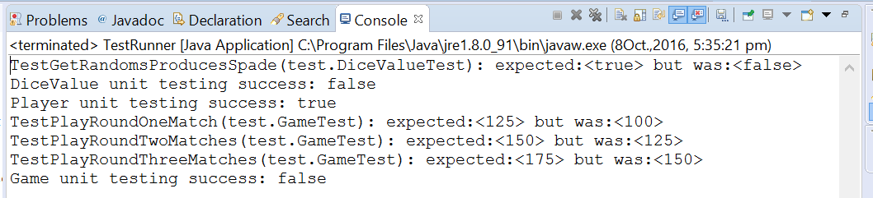

This result shows that the test failed. (The TestPlayRoundTwoMatches line is present, and it says “false” after “Game unit testing success:”)